Arushi Nety

ENGRD 2720

Deep Learning

Due: December 7, 2021

**Deep Learning Assignment**

**Part B: Changing batch size and epochs and retraining, training and testing error measured in terms of accuracy**

* 1. Keeping batch size = 128:

| Epoch | Training Error | Testing Error |
| --- | --- | --- |
| 5 | 0.5 | 0.69 |
| 10 | 0.65 | 0.82 |
| 20 | 0.77 | 0.88 |

* 1. Keeping epochs = 5:

| Batch Size | Training Error | Testing Error |
| --- | --- | --- |
| 128 | 0.5 | 0.69 |
| 256 | 0.3 | 0.47 |

* 1. Keeping epochs = 10:

| Batch Size | Training Error | Testing Error |
| --- | --- | --- |
| 128 | 0.65 | 0.82 |
| 256 | 0.57 | 0.8 |

* 1. Keeping epochs = 20:

| Batch Size | Training Error | Testing Error |
| --- | --- | --- |
| 128 | 0.77 | 0.88 |
| 256 | 0.7 | 0.81 |

* 1. Main Takeaways:
     1. Increasing epochs increases accuracy of neural network, shown in Table A
     2. Increasing batch size in some cases decreases accuracy, no real change between some, shown in Tables B, C, and D

**Plotting Training and Testing Error as a Function of Epochs**

One example: batch size = 256, epochs = 20:

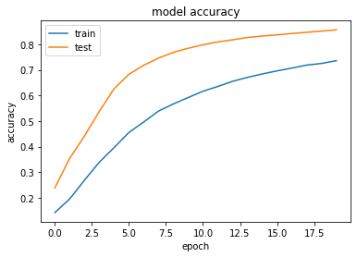

This was generated for each size/epoch combination.

**[More on the next page]**

**Part C: Use the neural network to classify my own handwriting**

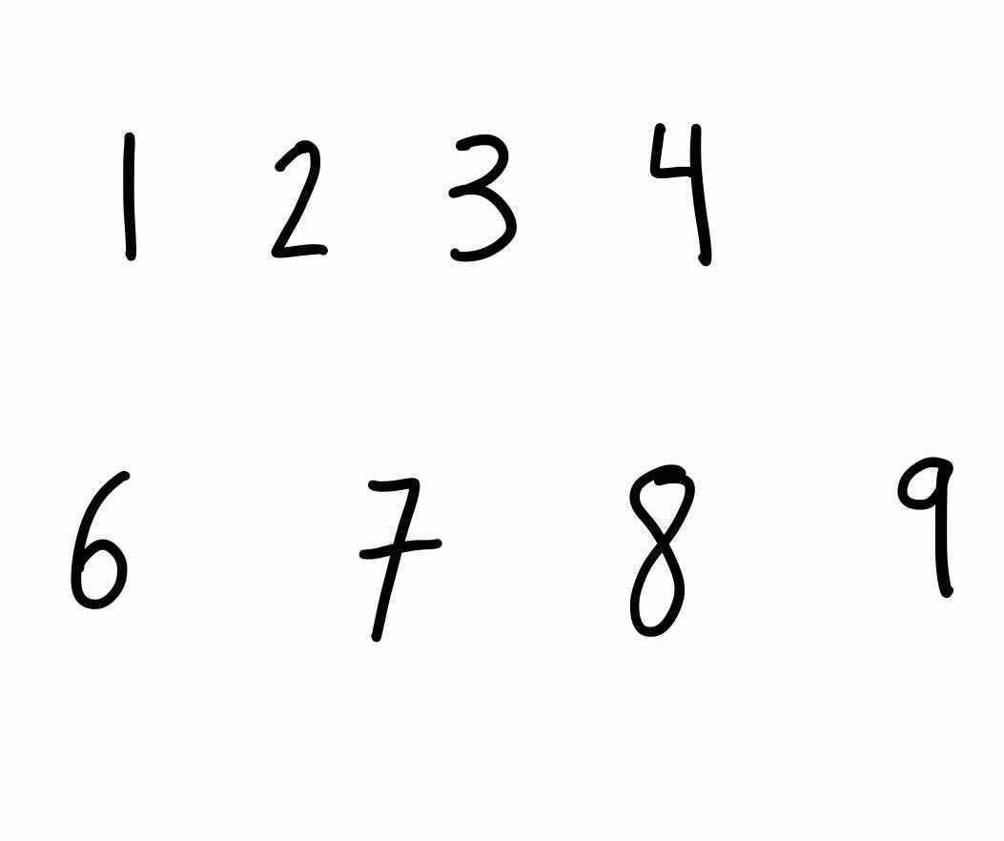

Results: Using batch size = 128, epochs = 20 since that was the combination with the highest accuracy

* 1. One: correctly predicted

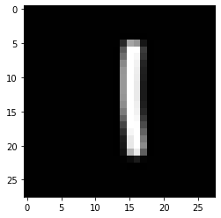

* 1. Two: incorrect prediction- thought it was 1

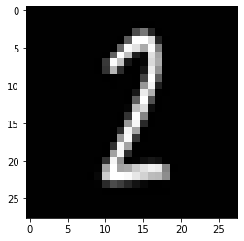

* 1. Three: correctly predicted

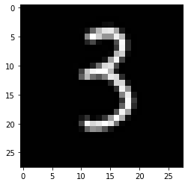

* 1. Four: incorrect prediction- thought it was 7

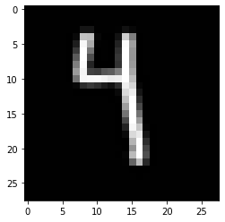

* 1. Five: correctly predicted

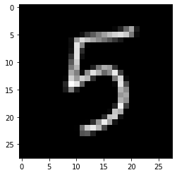

* 1. Six: correctly predicted

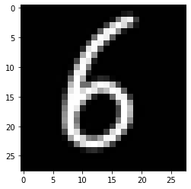

* 1. Seven: incorrect prediction- thought it was 1

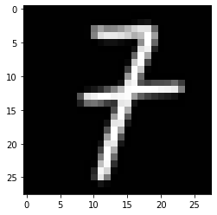

* 1. Eight: incorrect prediction- thought it was 3

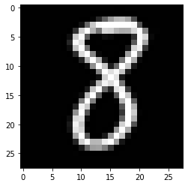

* 1. Nine: incorrect prediction- thought it was 3

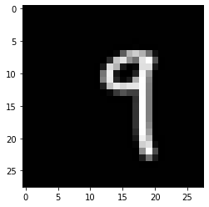

**Advanced**

**How does it perform with legibility problems:**

Different modes of writing: iPad versus Handwritten

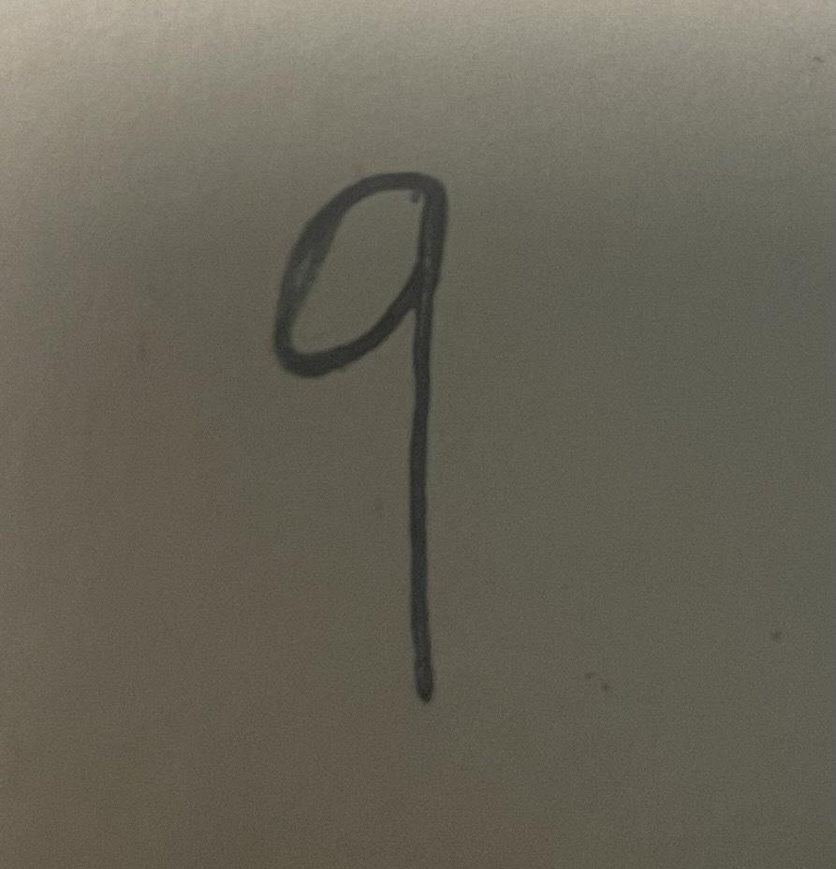

Using this form of a nine, the output image was distorted and blended the writing into the whiteness of the page, as depicted below. It’s prediction was a 5, which is different from the prediction from the number written on the iPad (3).

